**W1-S2** GROUP REFLECTION

*Design Principles*

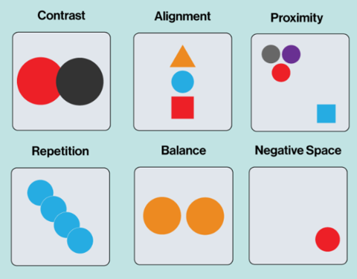

For this session: Make groups of 3 students.

|  |  |
| --- | --- |
|  | Group work *(60 min)* |

You need to need to analyze **3 graphical designs** (choose among the ones bellow)

* Complete the evaluation table for each analysis
* Propose improvements if needed *(just ideas. You don’t have to draw anything)*

|  |  |
| --- | --- |
|  | Group presentations *(15 min)* |

It’s time to share you group work to the whole class

* 1 speaker per group
* Speakers are randomly selected to present each group work activity

*WORK 1*

Which design you choose? (letter): A

|  |  |  |
| --- | --- | --- |
| *CATEGORY* | *CRITERIA* | *YOUR ANLAYSIS* |
| CONTRAST | * Does the design use enough contrast to differentiate elements? * Do the elements with high contrast stand out as intended? | * The design doesn’t use enough contrast to differentiate elements   ( Because all the texts have the same color)  -No it doesn’t ( because as I mention previously all the texts have the same color black-white) |
| ALIGNMENT | * Are text, images, and other elements aligned properly to create order and cohesiveness? * Are there any elements that feel "out of place"? | -Yes ( all the texts a line properly)  -No ( same reason) |
| PROXIMITY | * Are headlines, body text, and images that belong together placed near each other? * Are elements spaced too far apart or too close together? | -Yes (because line space looks balanced)  -No. |
| REPETITION | * Are colors, fonts, or shapes used consistently across the design? * Does the repetition feel intentional and effective? | -Yes.  -Not look affective at all. |
| WHITE SPACE | * Does the design have enough white space to avoid overcrowding, or does it feel empty? * Is the white space used to guide the viewer's eye effectively? | -No ( the margin look not suitable right margin should be shorter then before and top right of the margin look too empty)  -No. |
| BALANCE | * Is the design the same on both sides or does one side have more weight than the other? * Does the design feel even and comfortable to look at, or does it feel lopsided and uneven? | -The designs are the same on both sides but they are too simple.  -No. |
| **IMPROVEMENTS** | * Write your improvement proposition (*If any)* | **-Should have added more colors.**  **-Add Image of food men.** |

*WORK 2*

Which design you choose? (letter): D

|  |  |  |
| --- | --- | --- |
| *CATEGORY* | *CRITERIA* | *YOUR ANLAYSIS* |
| CONTRAST | * Does the design use enough contrast to differentiate elements? * Do the elements with high contrast stand out as intended? | No. some elements are too light and some are dark.  Yes, the element with high c. is big and catch attention user by the dark green |
| ALIGNMENT | * Are text, images, and other elements aligned properly to create order and cohesiveness? * Are there any elements that feel "out of place"? | Order, but not suitable  Yes, too randomly |
| PROXIMITY | * Are headlines, body text, and images that belong together placed near each other? * Are elements spaced too far apart or too close together? | No.  Yes, some are too. but some are okay |
| REPETITION | * Are colors, fonts, or shapes used consistently across the design? * Does the repetition feel intentional and effective? | No.  Yes, it feels intentional and yes because interesting |
| WHITE SPACE | * Does the design have enough white space to avoid overcrowding, or does it feel empty? * Is the white space used to guide the viewer's eye effectively? | No.  No, color background is not white. |
| BALANCE | * Is the design the same on both sides or does one side have more weight than the other? * Does the design feel even and comfortable to look at, or does it feel lopsided and uneven? | Yes, both sides are balance.  Yes, it is comfortable but a bit messed up. |
| **IMPROVEMENTS** | * Write your improvement proposition (*If any)* | **-color: headline and body text shouldn’t use too many colors**  **-size of images**  **-fonts of text and headline** |

*WORK 3*

Which design you choose? (letter): G

|  |  |  |
| --- | --- | --- |
| *CATEGORY* | *CRITERIA* | *YOUR ANLAYSIS* |
| CONTRAST | * Does the design use enough contrast to differentiate elements? * Do the elements with high contrast stand out as intended? | Not yet. It needed more color contrast and shape contrast.  The high contrast does not stand out enough, because it looked the same as other elements. |
| ALIGNMENT | * Are text, images, and other elements aligned properly to create order and cohesiveness? * Are there any elements that feel "out of place"? | They are not properly aligned yet because the navigation bar is on the left side of the page which makes it look unorganized, and the spaces are too far from the titles.  The contact information should be at the footer of the page. |
| PROXIMITY | * Are headlines, body text, and images that belong together placed near each other? * Are elements spaced too far apart or too close together? | Yes, but the space seems off and not aligned properly between the headlines and body texts.  The gaps are quite far apart. |
| REPETITION | * Are colors, fonts, or shapes used consistently across the design? * Does the repetition feel intentional and effective? | Yes, they are.  The repetition looks intentional since there is not much difference in font and color. |
| WHITE SPACE | * Does the design have enough white space to avoid overcrowding, or does it feel empty? * Is the white space used to guide the viewer's eye effectively? | The right side of the page and the footer feel empty, but the left side feels overcrowded.  Yes, it lets us know which texts belong to which headlines. |
| BALANCE | * Is the design the same on both sides or does one side have more weight than the other? * Does the design feel even and comfortable to look at, or does it feel lopsided and uneven? | No, it is not balanced because the left side is smaller than the right side.  It is uneven and lopsided. |
| **IMPROVEMENTS** | * Write your improvement proposition (*If any)* | * **Add image for visualization.** * **Add more color for the header.** * **Style the font for better looking.** |

*DESIGN A*

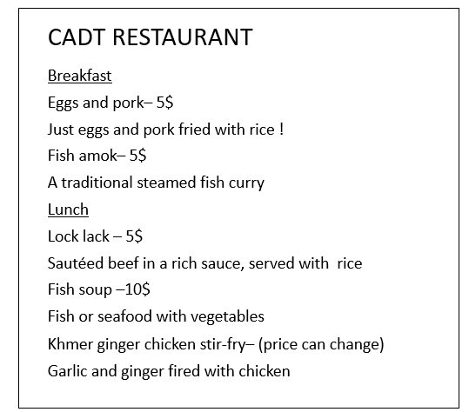

*DESIGN B*

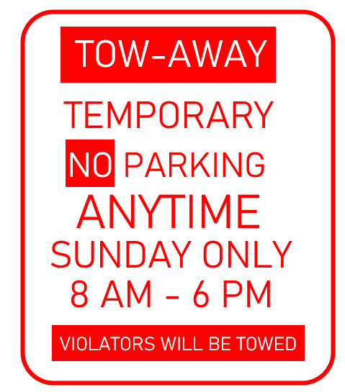

*DESIGN C*

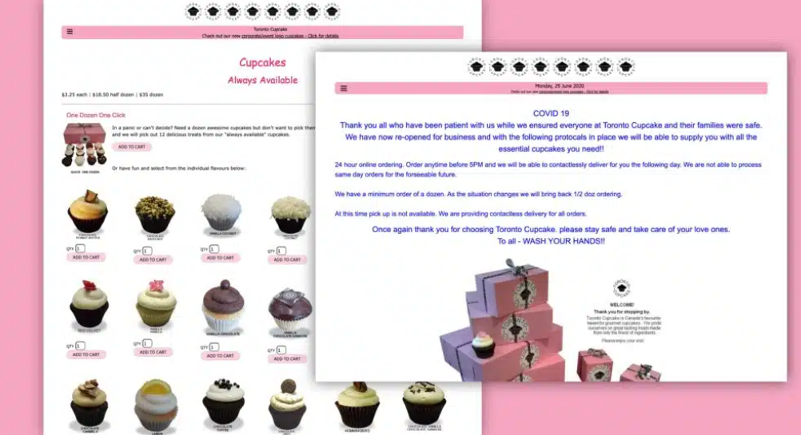

*DESIGN D*

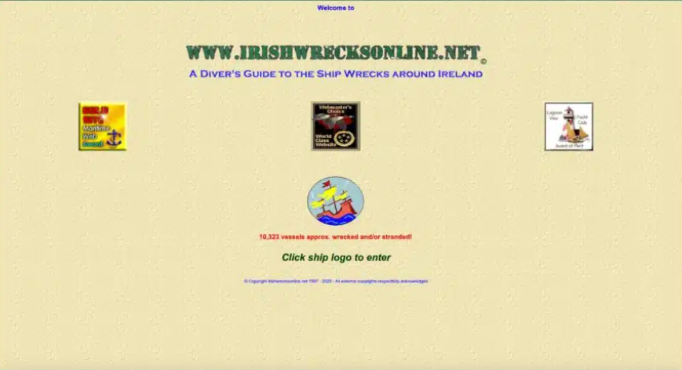

*DESIGN E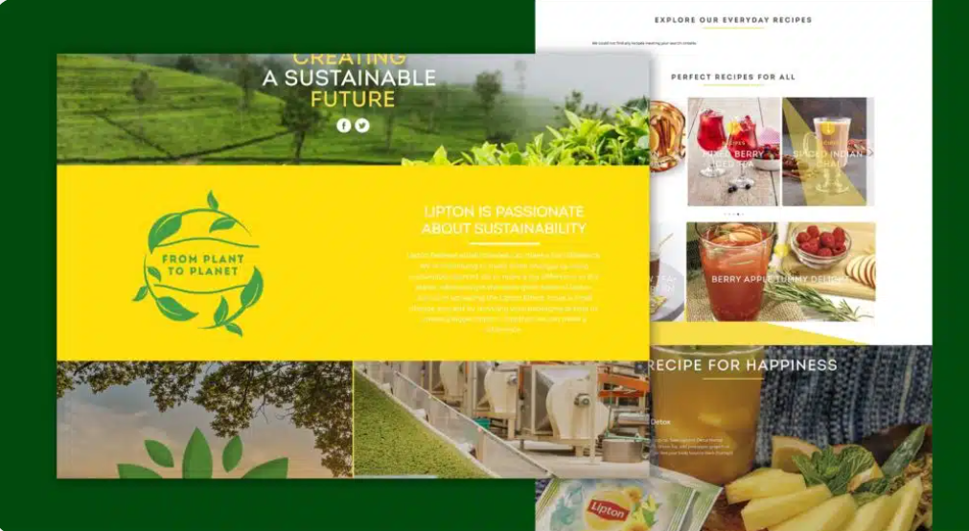*

*DESIGN F*

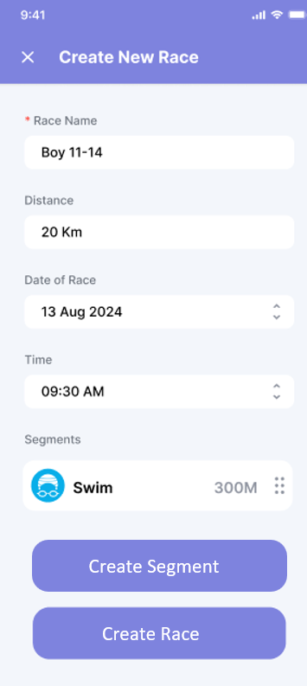

*DESIGN G*

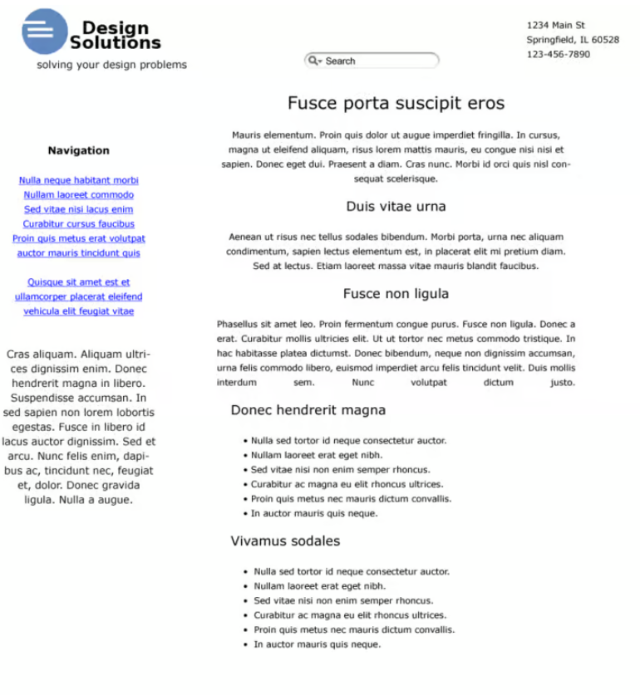

*DESIGN H*

